Enhancing Product Recommendations through Large Language Model and Significant Latent Core Factor SVD: Insights from Amazon Reviews

R.Dhayanidhi
Research Scholar
Dept of CSE
Vel Tech Rangarajan Dr.Sagunthala R & D Institute of Science and Technology, Chennai, India.
Dhayanidhi.r@gmail.com
N.R.Rajalakshmi
Professor
Dept of CSE
Vel Tech Rangarajan Dr.Sagunthala R & D Institute of Science and Technology, Chennai, India.
drnrrajalakshmi@veltech.edu.in

Abstract

In recent times, e-commerce provides more choices to the users along with the framework of e-commerce is more difficult. Unavoidably, it creates information overload problem. The resolution to this issue in e-commerce field is personalized recommendation model by ML (Machine Learning) approach. People frequently seem to be confused when experiencing extreme information and may not hold the significant points. Many existing studies have investigated product recommendation by SVD (Singular Value Decomposition). It is one of the most efficient technique to recommend products. However, it faces struggles when working with unseen data and it leads to delay or inappropriate recommendation of products. To overcome this problem, the proposed research employs significant latent core factor SVD. The proposed technique includes decomposing a large and spare matrix which deliberates real-time interactions of the users with the products into matrices that permitting the proposed model to forecast personalized product recommendation based on the existing data. The proposed research employs LLM (Large Language Model) to improvise the process of feature extraction with data imputing features after the existence of pre-processing. It helps to fill the missing values more accurately based on the existing data, which enhances the performance of proposed model and leads to personalized recommendations. The proposed research employs Amazon product review dataset to evaluate the proposed significant latent core SVD. The performance of the proposed model is evaluated by the performance metrics of MSE (Mean Square Error) and RMSE (Root Mean Square Error). When compare to traditional SVD, the proposed significant latent core factor SVD achieves less error rate.

Keywords: E-Commerce, Product Recommendation System, ML (Machine Learning), SVD (Singular Value Decomposition), LLM (Large Language Model)

1. Introduction

In past days, most of the users were depends on the expertise to take decision with respect to entertainment, commodities and news. Considering, the ancient years, the extensive development in the framework of digital data, especially on the internet which increases the problem of data overload [1]. Generally, data overload is defined as stress persuade acceptance of data than needed in the order to make decision and to handle with it by some practices in time management [2]. This problem limits the capability in reviewing conditions and picks in among several alternative commodities available in the online market. In divergence, to minimize the impact of this problem, information science and technology provided an answer through producing data filtering tools [3]. However, recommendation system is one of the tool that has developed in the early 90s. Typically, they are designed as a software tools for helping users in selecting items and other entities [4]. Through that time, the recommendation systems were a subject of other combined research fields such as IR (Information Retrieval) or HCI (Human Computer Interaction) [5]. In recent years, recommendation systems is an incorporated and well known tool in comprehensive of applications in esteems to e-commerce. Some websites relevant to e-commerce which employs several methods for creating the users endure good experience in online marketing, due to the novel and improved techniques such as collaborative based, content based and hybrid based to provide a better experience to the user throughout the shopping [6]. However, users experience some complications in discovering beneficial information from a massive database. Hence the recommendation system of e-commerce that is a fundamental activity where the users are offered with uninterrupted communication with merchants [7]. While, this structure is having some problems such as the appropriateness in the recommendation is not great as the products and boundaries of users are inadequately mined, to fulfill the demands of the user by single recommendation paradigm and finally, the static metrics and design lead to the inflexibility in recommendation system [8]. In technical perspective, broad recommendation system will operate with one approach or with more than one method namely CBF (Content-Based Filtering), DF (Demographic Filtering), CF (Collaborative Filtering) and KBF (Knowledge-Based Filtering) [9]. Preferences of users across unique items might be predicted by some of the ranking patterns which provide a list of recommended products through making personal assessment into prospect [10].

Generally, the architecture of RS rely the database that saves and sequentially updates the product and ratings description offered by the user. Due to this services, particularly filtering and clustering, the recommendation system is broadly employed in e-commerce which helps the users to get official and recent items [11]. Moreover, the products are recommended on the basis of similar metrics prevailing among items and users in collaborative filtering [12]. Generally, there are two types of collaborative filtering namely model based collaborative filtering and neighborhood based collaborative filtering. The neighborhood based collaborative filtering comprises user based and item based approaches [13]. Generally, the user based approach recommend the items that are liked by some users whoever having the same preferences and the item based recommend the items based on the similar properties [14]. Recently, several matrix factorization techniques are employed for collaborative filtering. Conversely, the item might be recommended on the basis of the product services or specifications employed while recommending in the content based filtering [15]. Generally, product recommendation depends on user preference models resultant from searches, shopping cart inclusions, likes, browsing history, orders, comments and favorites. By using LR (Logistic Regression), these model are trained in offline and evaluated by map reduce [16]. Moreover, the user client reporting pursues their shopping cart, browsing and clicking activities to offer real time feedback to the users [17]. By using spark or storm steaming evaluations, the real time user preferences are generated, even though the significant struggles of handling both user and product relationships and the combined demands on storage access and space performance for online services [18]. Consequently, the applicability of ML (Machine Learning) in e-commerce has wide-range forecasts and offers massive emergent opportunities for e-commerce enterprises [19]. Initially, ML can comprehend customized recommendation systems by analyzing huge product information and user data, thus enhancing shopping experience of users and purchase conversion range. It aids to comprehend extremely customized product recommendations that has majorly enhanced loyalty and purchase willingness of the users [20]. However, SVD is a robust tool in e-commerce for product recommendation. On the other side, it has several drawbacks sparsity, computational expenses and static nature. The traditional SVD struggles when unseen data is introduced that may delay the process of recommendation system. To overcome these problem, needs incorporating SVD with other enhanced techniques. Hence the proposed research introduces enhanced product recommendation model for Amazon products. The proposed research employs LLM (Large Language Model) to enhance the feature extraction process. It creates extra summaries or description of the products based on existing information. This aids to generate precise content for the recommendation model. To recommend the products, the proposed research employs significant latent core factor SVD. The proposed model is evaluated by Amazon product review dataset. The performance of the proposed model is evaluated by MSE (Mean Square Error) and RMSE (Root Mean Squared Error).

1.1 Research Contribution

The main objective of the proposed research is follows:
- To develop an efficient recommendation model for Amazon products using Amazon product review dataset.
- To enhance the feature extraction by using LLM which generates extra summaries or description of the products based on existing information
- To provide precise recommendation to the users about products by proposed significant latent core factor SVD.

1.2 Paper organization

The structure of the research paper is organized with overview in Section 1, the review of existing studies involved in recommendation system by diverse algorithms are deliberated in section 2 along with research gaps. Section 3 deliberates the proposed methodology and the process involved. The results achieved by the proposed model is represented in the Section 4. The conclusion and future work of the proposed model is represented in Section 5.

2. Literature Review

The study [21] demonstrated enhanced product demonstration method by collaborative filtering on the basis of triangle similarity. The approached study has considered common ratings and which were not generally rated by the pairs of uses. The study has been evaluated by the six dataset with satisfactory performance. Moreover, the study [22] has used product recommendation system based on hybrid model by enhanced Apriori algorithms. The study has employed PCA (Principle Component Analysis) for data reduction which has aided to minimize the complexity. The study has attained better performance with 0.7869. Besides, the study [23] implemented sentiment based product recommendation model by ML algorithms. The study has been evaluated by dataset from kaggle. The performance of the study has been evaluated by performance metrics of accuracy, precision, recall and F1-score. The objective of the study [24] has been forecast the ratings to recommend the products to the users by collaborative filtering algorithms which has included ALS (Alternated Least Squares), SVD (Singular Value Decomposition) along with to recommend products by KNNBasic (K-Nearest Neighbor). To detect the abnormalities K-means clustering has employed. The SVD techniques has been outperformed. Similarly, the study [25] has employed hybrid ML combination and clustering algorithm to recommend products for the users by k-means clustering algorithm and Apriori rule with satisfactory performance. Literally, the study [26] demonstrated product recommendation which included commodity data set and evaluating rankings of user with commodity interest. The study has employed fusion recommendation algorithm on the basis of frequent item set mining with better performance. Similarly, the study [27] has employed classification approach based on sentimental analysis by BH – GWO (Black Hole-based Grey Wolf Optimization) Fuzzy. The study optimized the approached technique by adaptive fuzzy classifier with better performance when compare to SVM (Support Vector Machine), Fuzzy, NN (Neural Network) and KNN. Literally, the study [28] demonstrated recommendation system in e-commerce by HAR – KNN (Hybrid Action-Related K-Nearest Neighbour) to deepen the user behavior matrix by feature vectors. The study has employed KNN to categorize the real-time and online users and analyze the similarity from huge target users from massive amount of data with average error value in MSE and RMSE with 0.7201 and 0.7322. Likewise, the study [29] has employed OCA (Ordered Clustering based Algorithm) to minimize the data sparsity and the cold start issues in E-commerce recommendation systems. The study has used collaborative filtering to groups the users depends on their preferences. The performance of the approach has been evaluated by the performance metrics. Correspondingly, the objective of the study [30] has implemented recommendation system to obtained precised outcomes based on the behavior of the customers and collaborating with mathematical analysis which has assisted for the decision making process in the E-commerce platform with satisfactory performance.

Moreover, the study [31] has demonstrated recommendation system on the basis of semantic context to investigate the semantic combinations among items achieved by using products by the users. To choose the top N neighbors, collaborative filtering and mining sequential patterns with satisfactory performance. Besides, the study [32] demonstrated DeepIDRS (Item Description and Review Based Deep Sequential Recommendation) by analyzing the review of the users. The study has been evaluated by the three real-world Amazon dataset. The study has two level hierarchical structure which has included bidirectional encoder to deliberate textual details of the item and attention based sequential recommendation model to embedding the details from the previous layer with better performance. Literally, the objective of the study [33] has to develop a recommendation system by RHRM (review of the helpfulness-based recommendation methodology) which has assisted for personalized recommendation. The study has incorporated CNN (Convolutional Neural Network) and Bi-LSTM (Bidirectional Long Short Term Memory). The respective study has been evaluated by the Amazon Book dataset with satisfactory performance. Similarly, the study [34] demonstrated SEMMRec (Semantic-Enabled Markov Model Recommendation) system that has feed metadata of products and purchase history of customers and extract the relevant semantic and sequential product knowledge according to the textual and usage characteristics through found resemblance among product based on their features by TF-IDF and Doc2vec of distributional hypothesis methods with average performance. Moreover, the study [35] has demonstrated hybrid recommendation system based on user collaborative filtering and content filtering. To swap the conventional user-item rating matrix, the study has combined user feature rating matrix and user rating with item features. The study has achieved satisfactory performance with k-means clustering. Besides, the study [36] demonstrated recommendation model of SCSHRS (Sparsity and Cold Start Aware Hybrid Recommended System) to overwhelm CSP and data sparsity in RS. The study has included 4 stages in each stages diverse techniques has been employed to enhance the process such as Ant Lion based k-means clustering has been used to group the similar users, HOSVD (Higher Order Singular Value Decomposition) has been used to minimize the dimensions of the data and finally ANFIS (Adaptive Neuro-Fuzzy Inference System) has been used to forecast the output with satisfactory performance. As the prevailing algorithms has faced some issues in user preferences and product relationships, ML methods like collaborative filtering and DL are involved in the study [37] for tackling the issues by enhancing the classification accuracy and personalized recommendations. Additionally, in order to tackle the issues, the study [38] has implemented the combination of collaborative filtering, Bayesian ranking with Light GBM and DNN, popularity-based method which has enhanced the accuracy with average values in terms of MAP@K and MAR@K. As the ML methods has faced several challenges such as data sparsity and reliability,[39] has utilized the collaborative filtering for tackling the issues of content related techniques and hybrid methods which are difficult along with a quality. The study [40] has tackled the overload information by utilizing the RSVD (Rating Singular Value Decomposition) and has obtained average level of accuracy in contrast with the collaborative filtering techniques and has dynamically tackled the sparsity issue.

The study [41] has utilized the PCA-SVD (Singular-Value Decomposition) for decreasing the dimensionality and the K-means for clustering for improving the image regarding the recommendations. The results has obtained average outcomes in terms of increased quality of cluster. Various ML methods like KNN baseline, CO-clustering and SVD has been suggested [42] for tackling the issues of producing appropriate and adapted recommendations. As a result, the suggested algorithms has been examined in terms of MSE, FCP, RMSE, MAE , NDCG which has been implemented to the GUI after the production of results for an enhanced performance. The study [43] has utilized the combination of collaborative and content based filtering has been suggested for tackling the problems of sparse data and transferring the user partialities. As a result, adaptive user communications and improved cooperation has been obtained. Also, KNN and matrix factorization with the utilization of SVD are involved in the study [44] for tackling the problems of cold start and inaccurate recommendations and has obtained average results in terms of precision and image quality by the hybrid method. Alternatively, the PHOTSVD (Parallel Higher-Order Tensor Singular-Value Decomposition) algorithm has been suggested [45] to control the numerous entities for stronger recommendations and for tackling the issues of cold start and data bias. As a result, the obtained PMRS has an average performance in contrast with the traditional; systems in terms of better quality. Similarly, SVD has been suggested by the study [46] for tackling the issues of accuracy, involvement of users and the computational effectiveness. The outcomes obtained by the study has enhanced the quality in terms of precision, recall and F1 score, click by rates and a stronger computing performance in recommendations. The study [47] has utilized SVD and its alternatives for tackling the issues of data sparsity, scalability and the cold start and the outcomes has incorporated the accuracy of recommendation in terms of metrics like spearman’s rank correlation coefficient and RMSE. Correspondingly, the study [48] has utilized the improved SVD with its adjacent neighbour’s techniques for enhancing the data clustering and classification which has purposed to decrease the usage of resource and enhance the performance of the system recommendation. Alternatively, the SVD algorithms has been implemented [49] with the utilization of MPI (Message Passing Interface), spark and hadoop for allowing the scalability and parallelization fir the issue of using the large scale data in the systems of recommendation. As a result, the outcomes obtained has enhanced the performance in contrast with the conventional systems. Subsequently, dynamic methods such as adaptive KNN with SVD ECF (Extended Collaborative Filtering) has been used by the study [50] for addressing the problem of data sparsity and cold start. As a result, enhanced recommendations has been obtained in the implementation of those algorithms.
2.1 Problem Identification

- The existing study has represented results based on single case study and it has included inadequate demographical data which has led to the reduction of overall quality of the customer groups [22].
- The limitations of the existing study has faced privacy issues and scalability during handle the information of the users [34].
- The limitations of the study [40] involves the need for excess appropriate content-based recommendation systems which has tackled the sparsity issues and frequently a restriction in collaborative filtering methods.

3. Research Methodology

In recommendation system, SVD plays a significant role because it potentially reduces the user-item interaction dimensionality matrix that improves the performance of the proposed. However, the traditional SVD faced some limitations. To address this, the proposed research employs significant latent core factor SVD. The overall process of proposed research is represented in figure 1.

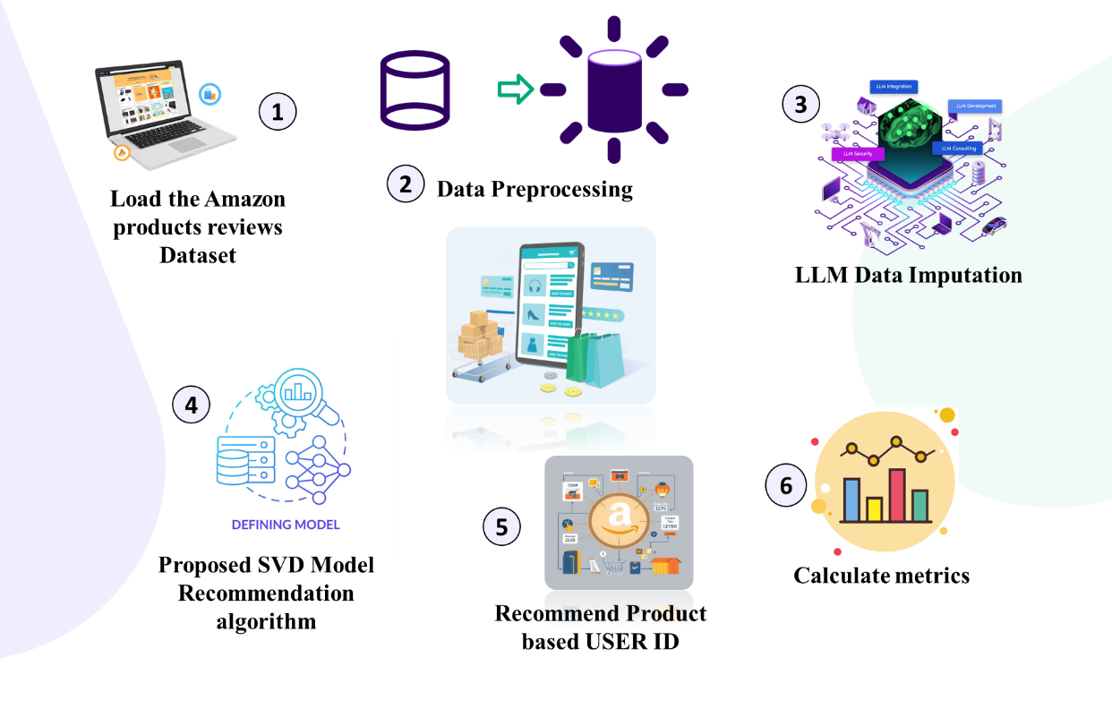
Figure 1. Overall Process of Proposed Research

Figure 1 depicts the overall process of proposed research. Initially, the proposed research load the Amazon product review dataset which includes the user ID, products purchased by the users, liked products and frequently searched products. The loaded dataset is processed with pre-processing however, there is a limitation in pre-processing, there is massive difference among actual rating and filling rating during the pre-processing. To resolve this issue, the proposed research employs LLM with data imputing features which is train by the dataset and aids to fill the data more accurately when compare to the pre-processing. The processed data is fed as an input to the proposed significant latent code SVD which aids to minimize the sparse and large matrices dimensionality which deliberate interaction of users with products. This drop seizures latent factors leveraging preferences of user and characteristics of item that permitting for more precise recommendation. By employing the proposed significant latent core factor SVD. The products are recommended to the users based on their user ID. Finally, the performance of the proposed model is evaluated by MSE and RMSE.

3.1 Dataset Description

The proposed research employs Amazon product review dataset. The dataset link is provided below for the reference:https://www.kaggle.com/datasets/asaniczka/amazon-products-dataset-2023-1-4m- products?select=amazon_products.csv. Amazon is one of the largest retailers in the USA which retails across 12 million products throughout the world. This dataset includes best sell products, the optimal range for a product in a provided category, which SEO (Search Engine Optimization) headings produce the most sales. The respective dataset includes 1.4 million details of Amazon products which contains heading, ratings, sales data and number of reviews from September 2023.

3.2 Pre-Processing

The proposed research employs pre-processing is to convert the raw data into structured data. This process improves the accuracy of proposed research by confirming which the dataset provided into algorithm is relevant, clean and exact format. This involves correcting errors by removing irrelevant data that aids the proposed model to make precise predictions on the basis of high quality data. The quality of dataset is majorly enhanced by using pre-processing techniques like data transformation and noise reduction. This contains encoding the classified variables, removing outliers and normalizing data that permits proposed model to concentrate on the more information perspective of the data. The proposed research employs LLM to fill the missing values efficiently which enhance the recommendation system of the proposed model.

3.3 Data Imputing Large Language Model

The conventional techniques for managing missing values such as KNN, mean imputation and GAN, however it fails to seizure the complicate relationship between variables. In existing studies, the GAN might struggled with the deepness of semantic interpretation is needed for efficient recommendations. Additionally, the conventional GAN focused on creating new data sample. While, the proposed LLM may offer dynamic recommendations on the basis of real time interactions of user and contextual data. The proposed LLM have the ability to analyze massive amount of data which includes product details and user reviews. Because the proposed LLM technique is the association of BART (Bidirectional and Auto-Regressive Transformer) and GPT (Generative Pre-trained Transformer). Due to this combination, the LLM recommend personalized products more precisely than other models. The LLM might be modified to perceptively forecast and fill the missing data on the basis of prevailing data points. During the pre-processing, the missing values are filled using LLM approach. LLM produces a prompt which employs obtainable information to gather the missing variables. This process offers statistical imputations along with confirms which the attributed values are somatically meaningful. Through elevating the datasets using precise imputed values, the LLM simplify a more wide range insights of item characteristics and user behavior. This led to more customized and related recommendation, which efficiently tackle the problems such as data sparsity which frequently delay the conventional recommendation model. Moreover, LLM may aid to diminish the cold start issue using general knowledge and combinations acquired from huge quantity of text data, permitting them to recommend most relevant products even with less user interaction history. This represents that the LLM is performs well when compare to other existing approaches.

3.4 Proposed Methodology
3.4.1 Traditional SVD

The conventional product recommendation model uses the collaborative filtering based technique to recommend products to the users in terms of their preference. The figure 2 represent the process of conventional SVD.

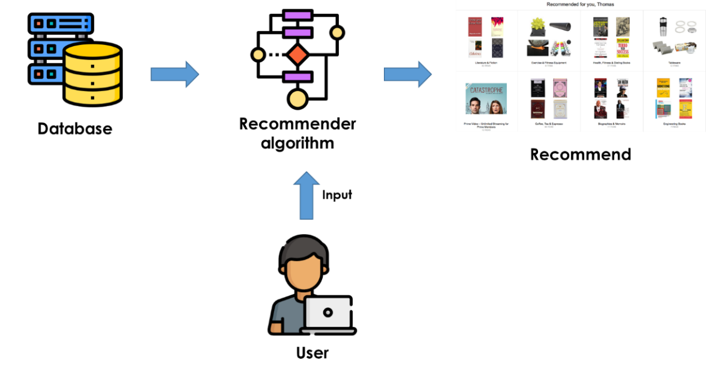
Figure 2. Process of Traditional Product Recommendation

Figure 2 represents the process of traditional product recommendation. The process begins with collection of dataset from Amazon product review dataset is provided as an input to the traditional recommendation model. The conventional SVD uses collaborative filtering process to recommend products to the customers. This collaborative filtering seizure various collection of user preferences. On the basis of the dataset, to ensure the product recommendation by comprise the ratings of active users. Through employing SVD, the collaborative filtering uses matrix factorization technique which collapse into lesser dimensional matrices from user item matrix which signifying latent factors. The user item matrix comprises ratings of users for several products in the circumstances of product recommendation model. Typically, SVD may forecast relationships and unseen patterns among users and products by collapse the matrix. The system includes all products of the dataset which users have not rated to create recommendation. To obtain forecasted scores, these unrated products are process by the collaborative filtering model by SVD. On the basis of previous ratings, the forecasted scores identify the actual products purchased by the users. While, this conventional SVD approach employed for less rank preference of rating matrix. On the other side, the conventional SVD is not able to handle the maximum portion of unseen ratings.

3.4.2 Proposed Significant Latent Core Factor SVD

To tackle the problem faced by traditional SVD, the proposed research employs the significant latent core factor SVD. This technique enhance the proposed model by accurate recommendation of products to the users. The entire process of proposed research is represented in the figure 3.

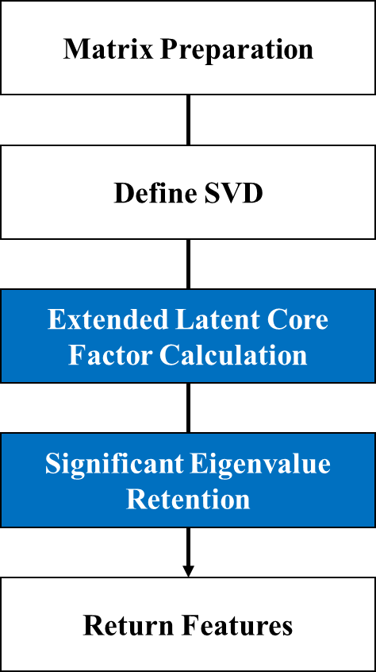

Figure 3. Entire Process of Proposed Model
Figure 3 depicts the entire process of proposed model. After pre-processing, the organized and filled dataset initiate the matrix preparation for user item matrix. The matrix form is fed as an input to the traditional SVD, due to challenges faced by the traditional SVD, the proposed research includes extended latent core factor calculation. It is an important method employed in product recommendation models. The proposed extended latent core factor technique improves conventional SVD by concentration on seizing more refined relationships in the dataset. Through maintaining a huge set of singular vectors and values, this proposed approach may perform better in the primary structure of item attributes and user preferences. This techniques is especially helpful in a situation with spare data, which permits for more precise forecast of user ratings for unseen data. The proposed extended latent core factor evaluation plays a significant role in enhancing the relevance and precision of product recommendations through influencing extreme visions from the interaction of user – item matrix. Followed by, the proposed research employs significant Eigen value retention. Maintaining significant eigenvalues is important because which associate straight with the most leverage latent factors. Through concentrating on these essential values, the proposed model may potentially seizure the primary form of the dataset however filtering out less relevant and noisy information. This is frequently obtained by choosing a threshold methods to estimate that singular values to maintain on the basis of their magnitude. When using this approach in the product recommendation system, it maintaining only the prime singular values permits for a low rank appropriation of the fundamental matrix. This appropriation shortens evaluations and improves prediction accuracy for unseen interaction of user – item matrix. In the circumstances of matrix factorization, the primary idea is to represent each user $u$ and $g$ group with low dimension latent factors $m_{u}$ and $m_{p}$. According to the equation (1), the dyadic rating $r\left(u,p\right)$ to user $u$ to group $p$ is generally appropriated,
$r_{b}\left(u,p\right)=m_{u}^{T}m_{p}$ (1)
Where, the rating forecast among $u$ and $p$ is denoted by $r_{b}\left(u,p\right)$, that is evaluated by the technique of latent core factorization. The primary form of matrix factorization technique may not seizure unambiguous characteristics. The process of proposed significant latent core factor SVD is represented in the pseudo code 1.
Pseudo Code 1: Process of Proposed Significant Latent Core Factor SVD
$$function ser_svd(X, k)$$
$$Input:$$
$$X - p x q matrix$$
$$k - number of desired singular values (k << min(p, q))$$
$$Output:$$
$$val_U- p x k matrix of left singular vectors$$
$$val_Σ - k x k diagonal matrix of singular values$$
$$val_V - q x k matrix of right singular vectors$$
$$// Step 1: Initialize$$
$$p, q = dimensions of X$$
$$v_{1} = random vector of size n$$
$$v_{1} = v_{1} / ||v_{1}|| // Normalize v_{1}$$
$$val_V = [] // Matrix to store orthonormal vectors$$
$$a = [] // Diagonal elements$$
$$b = [] // Off-diagonal elements$$
$$// Step 2: Significant Eigenvalue Retention Iteration$$
$$for j from 1 to k do$$
$$// Compute w = X * v_{j}$$
$$w = X * v_{1}$$
$$// Orthogonalize w against previous vectors$$
$$for i from 1 to j do$$
$$α[i] = v_{i}^{T} * w // Inner product$$
$$w = w - a[i] * v_{i} // Remove component in direction of v_{i}$$
$$end for$$
$$// Compute b$$
$$if j > 1 then$$
$$w = w - b[j-1] * v_{\left\{j-1\right\}}$$
$$end if$$

$$// Normalize w to get v_{\left\{j+1\right\}}$$
$$b[j] = ||w|| // Norm of w$$
$$if b[j] > 0 then$$
$$v_{\left\{j+1\right\}} = w / b[j] // Normalize$$
$$end if$$
$$V.append(v_{\left\{j\right\}}) // Store the orthonormal vector$$
$$a[j] = v_{j}^{T} * (X * v_{j}) // Compute a[j]$$
$$end for$$
$$// Step 3: Construct Tridiagonal Matrix T$$
$$T = tridiagonal_matrix(a, b)$$
$$// Step 4: Compute eigenvalues and eigenvectors of T$$
$$λ, Z = eigen_decomposition(T)$$
$$// Step 5: Obtain singular values$$
$$Σ = diag(sqrt(λ)) // Singular values$$
$$// Step 6: Compute val_U and val_V$$
$$val_U = [] // Initialize val_U$$
$$for j from 1 to k do$$
$${val_U }_{j} = (X * v_{j}) / Σ[j] // Compute left singular vectors$$
$$val_U.append({val_U}_{j})$$
$$end for$$
$$return val_U, val_Σ, val_V$$
$$end function$$

The function of proposed significant latent core factor SVD which takes two inputs such as $X$ is the large matrix that need to analyze and $k$ is a singular values need to identify. Initially, the matrix dimension of $X$ is estimated and the $v_{1}$ random vector of $n$ size is created and normalized to confirm it has a unit length. To store diagonal elements and orthonormal vectors, two null lists are created such as$val_V$ and $a$. Where, $b$ stores another list for off-diagonal elements. The proposed significant latent core factor SVD runs for $k$ iterations. A new vector $w$ is evaluated using multiplying the matrix $X$ in each iteration for the present vector $v_{j}$. To confirm that all vectors endure orthonormal, this vector is orthogonalized beside all existing calculated vectors. This includes evaluating inner products and altering $w$ through subtracting modules in the ways of existing vectors. If the process in not in the initial iteration, an extra modification is created by minimizing a scaled version of existing vector. The standard of $w$ is evaluated and keep in$b\left[j\right]$, once orthogonalization. If the standard is higher than zero, it is employed to normalize $w$, which producing the next $v_{\left\{j+1\right\}}$ orthonormal vector. Afterwards, the present vector is included in to $val_V$ and iteration of the diagonal element is evaluated as the $v_{j}$ inner product. The $tridiagonal_matrix$ $T$ is constructed by the $a$ diagonal elements and $b$ off-diagonal elements. This matrix seizures the significant information is required for the decomposition of eigenvalue. Where$λ$ and$Z$ are the eigenvalues and eigenvectors of the $T$ are calculated. These eigenvalues parallel to squared singular values. The singular values are achieved by captivating the square root of $λ$ and generating a diagonal matrix $Σ$. Where, $val_U$ is the left singular values which are calculated by converting each orthonormal vector by $X$ and normalizing through its parallel singular value. Lastly, the following function returns $val_U, val_Σ$ and $val_V$ three matrices that shows left singular vectors, singular values along with right singular vectors. Thus, the efficacy of the SVD is enhances by proposed extend latent core factor calculation with significant eigenvalue retention along with improves the significance of recommendations through influencing the most significant latent factors which leverage product characteristics and user behavior. This resultant to more accurate and personalized product recommendations to the customers.

4. Result and Discussion

This section deliberates the experimental outcomes of the proposed significant latent core factor SVD for personalized product recommendation.

4.1 Performance Metrics
Performance metrics are primarily used for observing the efficiency of the proposed research by utilizing metrics like RMSE and MSE value.
- MSE
It is the measurement of image excellence metric. If the standards are nearer to zero, the metric dimension have better quality. The formula for MSE is mentioned in equation (2)
$MSE=\frac{1}{n } \sum_{i=1}^{n}{{\left(Y_{i}-Y_{i}\right)}^{2}}$ (2)

- RMSE
Root Mean Squared Error is deliberated as the standard deviation of difference between residuals such as actual and predicted values. Lesser RMSE values denotes that the data fits well whereas high RMSE values suggest with less precise predictions and greater errors. RMSE is calculated using equation (3)
$RMSE= \sqrt{\sum_{i=1}^{N}{{\left( acutal-predicted\right)}^{2}}} /N$ (3)

4.2 EDA (Exploratory Data Analysis)

This section deliberates the experimental outcomes of the proposed significant latent core factor SVD.
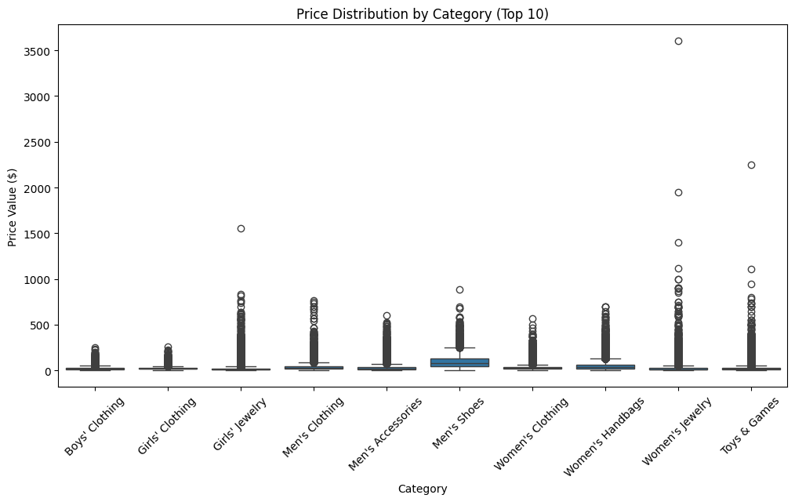
Figure 4. Price Distribution by Category

Figure 4 depicts the price distribution by category of top 10 products. Each classification has an important count of outliers that recommends that some of the items are extremely costly and most of the products are reasonably priced. In this plot, Men’s Shoes, Women’s Jewelry and Toys & Games have maximum outliers with prices beyond 3500 dollars. Most of the products in the categories are cheap, still a minimum percentage of high end or luxury items drive the extreme prices.
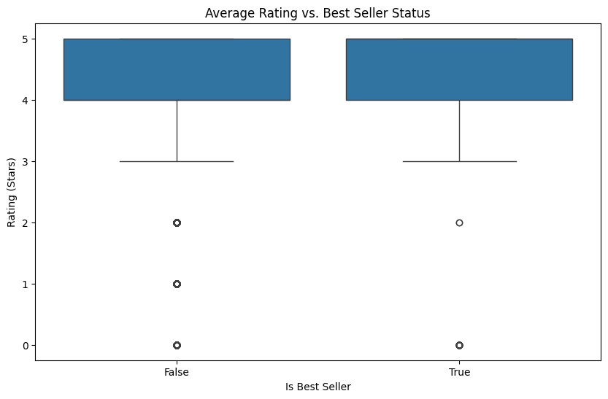
Figure 5. Analysis of Average Rating and Best Seller Status

Figure 5 depicts the average rating verses best seller status. This plot evaluates the distribution of average ratings provided by the uses for products in terms of their best seller status. The plot represents both there is a 4.5 star rating for both non-best selling and best-selling products. The whiskers represent that ratings in both groups are low as 3 stars which includes few extensive outliers dropping below rating of 2 stars and without star rating. The high rating is not extensive to best sellers, while best sellers represent les variability in ratings provided by the customers.

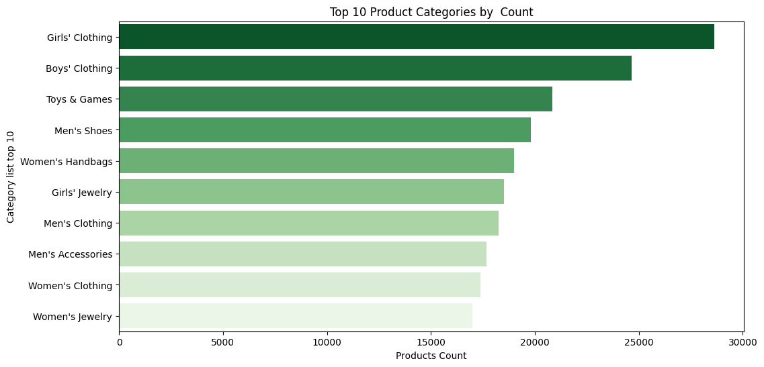

Figure 6. Top 10 Product Categories by Count

Figure 6 depicts the top 10 product categories by count. The plots shows that the highest product count is achieved by Girls’ Clothing with 30000, the next position is achieved by Boys’ Clothing with 25000. The least count is achieved by Women’s Jewelry with 170000 of count.

4.3 Performance Analysis

Table 1. Performance Analysis of MSE
Model/metrics | MSE
Traditional SVD | 0.4585
Proposed SVD | 0.3246

Figure. 7 Performance Analysis of MSE

Table 1 represent the performance analysis of MSE. The proposed research compare the performance of traditional SVD with proposed SVD. Where the proposed SVD achieves less error time with 0.3246 when compare to traditional SVD with 0.4585. The graphical representation of table 1 is depicted in the figure 7.

Table 2. Performance Analysis of MSE

Model/metrics | RMSE
Traditional SVD | 0.6771
Proposed SVD | 0.5696

Figure. 8 Performance Analysis of MSE

Table 2 represent the performance analysis of RMSE. The proposed research compare the performance of traditional SVD with proposed SVD. Where the proposed SVD achieves less error time with 0.5696 when compare to traditional SVD with 0.6771. The graphical representation of table 2 is depicted in the figure 8.

4.4 Comparative Analysis
Table.3 Comparative Analysis of RMSE with Existing Methods
Model/metrics | RMSE
Existing UTER [51] | 0.9825
Existing MCNN [52] | 0.9475
Proposed SVD | 0.5696

Table.3 depicts the comparative analysis of the existing UTER and MCNN which has the RMSE of 0.9825 and 0.9475 whereas the proposed SVD model has obtained lower RMSE value of 0.5696 in contrast to the existing models.

Figure.9 Comparative Analysis of RMSE with Existing Methods
Figure.9 depicts the comparative analysis of the existing UTER and MCNN which has the RMSE of 0.9825 and 0.9475 whereas the proposed SVD model has obtained lower RMSE value of 0.5696 in contrast to the existing models.

5. Conclusion and Future Work

The product recommendation system has enhance the performance of e-commerce field by evaluating the ratings and reviews of the customers. Most of the existing studies have employed content based collaborative filtering and SVD. SVD has considered as an efficient approach for product recommendation. However, the limitations of the SVD delay the process of recommend the products to the customers more precisely which SVD struggled with unseen data. To address this problem, the proposed research has employed significant latent core factor SVD to recommend the products to the customers based on their previous ratings and purchases. The proposed research has used LLM to enhance the process of feature extraction. It has aided to forecast the missing values and filled with prevailing data. Along with it accurately recommended the product even there has been minimal amount of data. The proposed significant latent core factor SVD has been evaluated by Amazon product review dataset. The performance of proposed significant latent core factor SVD has been evaluated by MSE and RMSE. When compare to traditional SVD, the proposed significant latent core factor SVD has achieved best performance with 0.3246 and 0.5696. The future work of the proposed research will be focus of other developing fields with enhanced personalization recommends based on their existing data.

References
[1] C. Li, I. Ishak, H. Ibrahim, M. Zolkepli, F. Sidi, and C. J. I. A. Li, "Deep Learning-Based Recommendation System: Systematic Review and Classification," IEEE Access, 2023.
[2] D. Roy and M. J. J. o. B. D. Dutta, "A systematic review and research perspective on recommender systems," Journal of Big Data, vol. 9, no. 1, p. 59, 2022.
[3] H. Zhou, F. Xiong, and H. J. A. S. Chen, "A comprehensive survey of recommender systems based on deep learning," Applied Sciences, vol. 13, no. 20, p. 11378, 2023.
[4] A. Da’u and N. J. A. I. R. Salim, "Recommendation system based on deep learning methods: a systematic review and new directions," Artificial Intelligence Review, vol. 53, no. 4, pp. 2709-2748, 2020.
[5] M. Nasir and C. I. J. S. C. S. Ezeife, "A survey and taxonomy of sequential recommender systems for e-commerce product recommendation," J SN Computer Science, vol. 4, no. 6, p. 708, 2023.
[6] A. Torkashvand, S. M. Jameii, A. J. N. C. Reza, and Applications, "Deep learning-based collaborative filtering recommender systems: A comprehensive and systematic review," Neural Computing Applications, vol. 35, no. 35, pp. 24783-24827, 2023.
[7] A. Daza, N. D. G. Rueda, M. S. A. Sánchez, W. F. R. Espíritu, and M. E. C. J. I. J. o. I. M. D. I. Quiñones, "Sentiment Analysis on E-Commerce Product Reviews Using Machine Learning and Deep Learning Algorithms: A Bibliometric Analysisand Systematic Literature Review, Challenges and Future Works," International Journal of Information Management Data Insights, vol. 4, no. 2, p. 100267, 2024.
[8] A. Suresh, M. Carmel, and M. J. I. J. o. A. S. Belinda, "A comprehensive study of hybrid recommendation systems for e-commerce applications," International Journal of Advanced Science Technology vol. 29, no. 3, pp. 4089-4101, 2020.
[9] L. J. M. I. S. Liu, "e‐Commerce Personalized Recommendation Based on Machine Learning Technology," Mobile Information Systems, vol. 2022, no. 1, p. 1761579, 2022.
[10] K. Wu and K. J. Chi, "Enhanced e-commerce customer engagement: A comprehensive three-tiered recommendation system," Journal of Knowledge Learning Science Technology vol. 2, no. 3, pp. 348-359, 2023.
[11] N. Chabane et al., "Intelligent personalized shopping recommendation using clustering and supervised machine learning algorithms," Plos one, vol. 17, no. 12, p. e0278364, 2022.
[12] A. Hasan, Z. B. Yusof, and M. J. I. J. o. A. M. L. Karim, "Machine Learning Algorithms for Personalized Product Recommendations and Enhanced Customer Experience in E-Commerce Platforms," International Journal of Applied Machine Learning, vol. 4, no. 11, pp. 1-15, 2024.
[13] S. Sharma, V. Rana, and V. J. I. J. o. I. M. D. I. Kumar, "Deep learning based semantic personalized recommendation system," International Journal of Information Management Data Insights, vol. 1, no. 2, p. 100028, 2021.
[14] H. Bastani, P. Harsha, G. Perakis, D. J. M. Singhvi, and S. O. Management, "Learning personalized product recommendations with customer disengagement," Manufacturing Service Operations Management, vol. 24, no. 4, pp. 2010-2028, 2022.
[15] J. Xu, Z. Hu, and J. J. J. o. I. P. S. Zou, "Personalized product recommendation method for analyzing user behavior using DeepFM," Journal of Information Processing Systems, vol. 17, no. 2, pp. 369-384, 2021.
[16] D.-N. Nguyen, V.-H. Nguyen, T. Trinh, T. Ho, H.-S. J. J. o. O. I. T. Le, Market,, and Complexity, "A personalized product recommendation model in e-commerce based on retrieval strategy," Journal of Open Innovation: Technology, Market, Complexity, vol. 10, no. 2, p. 100303, 2024.
[17] A. Nikolajeva and A. J. E. Teilans, "Machine Learning Technology Overview In Terms Of Digital Marketing And Personalization," ECMS, pp. 125-130, 2021.
[18] N. R. J. J. o. A.-A. S. D. Mitta, "Enhancing E-Commerce with Deep Learning: Techniques for Personalized Recommendations, Customer Segmentation, and Dynamic Pricing," Journal of AI-Assisted Scientific Discovery, vol. 3, no. 2, pp. 496-534, 2023.
[19] C.-Z. Tsai, H. Huang, C.-J. Wei, and M.-C. Chiu, "Apply deep learning to build a personalized attraction recommendation system in a smart product service system," in Leveraging Transdisciplinary Engineering in a Changing and Connected World: IOS Press, 2023, pp. 151-160.
[20] R. J. K. Almahmood and A. J. A. S. Tekerek, "Issues and solutions in deep learning-enabled recommendation systems within the e-commerce field," vol. 12, no. 21, p. 11256, 2022.
[21] A. Iftikhar, M. A. Ghazanfar, M. Ayub, Z. Mehmood, and M. J. I. A. Maqsood, "An improved product recommendation method for collaborative filtering," IEEE Access, vol. 8, pp. 123841-123857, 2020.
[22] M. R. R. Renukadevi, K. Sathishkumar, E. Boopathi Kumar, S. Janarthanam, Azimov Abdikhamidullo Kholmanovich, "An Improved Collaborative User Product Recommendation System Using Computational Intelligence with Association Rules " Communications on Applied Nonlinear Analysis, vol. 31, 2024.
[23] N. Vaishnavi and B. J. J. o. E. S. Kalpana, "Sentiment Based Product Recommendation System Using Machine Learning Techniques," Journal of Engineering Science Technology Review, vol. 17, no. 1, 2024.
[24] N. Padhy, S. Suman, T. S. Priyadarshini, and S. J. E. P. Mallick, "A Recommendation System for E-Commerce Products Using Collaborative Filtering Approaches," Engineering Proceedings, vol. 67, no. 1, p. 50, 2024.
[25] C. Udokwu, R. Zimmermann, F. Darbanian, T. Obinwanne, and P. J. P. C. S. Brandtner, "Design and Implementation of a Product Recommendation System with Association and Clustering Algorithms," Procedia Computer Science, vol. 219, pp. 512-520, 2023.
[26] L. Kang and Y. J. H. Wang, "Efficient and accurate personalized product recommendations through frequent item set mining fusion algorithm," Heliyon, vol. 10, no. 3, 2024.
[27] N. Ramshankar and P. J. S. Joe Prathap, "A novel recommendation system enabled by adaptive fuzzy aided sentiment classification for E-commerce sector using black hole-based grey wolf optimization," Sādhanā, vol. 46, no. 3, p. 125, 2021.
[28] S. G. K. Patro et al., "A hybrid action-related K-nearest neighbour (HAR-KNN) approach for recommendation systems," IEEE Access, vol. 8, pp. 90978-90991, 2020.
[29] Y. Gulzar, A. A. Alwan, R. M. Abdullah, A. Z. Abualkishik, and M. J. S. Oumrani, "OCA: ordered clustering-based algorithm for E-commerce recommendation system," Sustainability vol. 15, no. 4, p. 2947, 2023.
[30] F. T. Abdul Hussien, A. M. S. Rahma, and H. B. J. S. Abdulwahab, "An e-commerce recommendation system based on dynamic analysis of customer behavior," Sustainability, vol. 13, no. 19, p. 10786, 2021.
[31] M. Nasir, C. I. Ezeife, A. J. S. N. A. Gidado, and Mining, "Improving e-commerce product recommendation using semantic context and sequential historical purchases," Social Network Analysis Mining, vol. 11, no. 1, p. 82, 2021.
[32] I. Islek, S. G. J. E. C. R. Oguducu, and Applications, "A hierarchical recommendation system for E-commerce using online user reviews," Electronic Commerce Research Applications, vol. 52, p. 101131, 2022.
[33] Q. Li, X. Li, B. Lee, and J. J. A. S. Kim, "A hybrid CNN-based review helpfulness filtering model for improving e-commerce recommendation Service," Applied Sciences, vol. 11, no. 18, p. 8613, 2021.
[34] M. Nasir, C. I. J. I. J. o. D. S. Ezeife, and Analytics, "Semantic enhanced Markov model for sequential E-commerce product recommendation," International Journal of Data Science Analytics, vol. 15, no. 1, pp. 67-91, 2023.
[35] L. Li, Z. Zhang, and S. J. S. P. Zhang, "Hybrid algorithm based on content and collaborative filtering in recommendation system optimization and simulation," Scientific Programming, vol. 2021, no. 1, p. 7427409, 2021.
[36] S. G. K. Patro, B. K. Mishra, S. K. Panda, R. Kumar, H. V. Long, and D. J. S. C. Taniar, "Cold start aware hybrid recommender system approach for E-commerce users," Soft Computing, vol. 27, no. 4, pp. 2071-2091, 2023.
[37] K. Xu, H. Zhou, H. Zheng, M. Zhu, and Q. J. Xin, "Intelligent Classification and Personalized Recommendation of E-commerce Products Based on Machine Learning," arXiv preprint arXiv:.19345 2024.
[38] D.-N. Nguyen, V.-H. Nguyen, T. Trinh, T. Ho, and H.-S. J. Le, "A personalized product recommendation model in e-commerce based on retrieval strategy," Journal of Open Innovation: Technology, Market, Complexity vol. 10, no. 2, p. 100303, 2024.
[39] M. Loukili, F. Messaoudi, and M. J. El Ghazi, "Machine learning based recommender system for e-commerce," IAES International Journal of Artificial Intelligence vol. 12, no. 4, pp. 1803-1811, 2023.
[40] F. Colace, D. Conte, M. De Santo, M. Lombardi, D. Santaniello, and C. J. Valentino, "A content-based recommendation approach based on singular value decomposition," Connection Science vol. 34, no. 1, pp. 2158-2176, 2022.
[41] S. K. Addagarla and A. Amalanathan, "Probabilistic Unsupervised Machine Learning Approach for a Similar Image Recommender System for E-Commerce," Symmetry vol. 12, no. 11, p. 1783, 2020.
[42] W.-E. Kong, T.-E. Tai, P. Naveen, and H. A. J. Santoso, "Performance evaluation on E-commerce recommender system based on KNN, SVD, CoClustering and ensemble approaches," Journal of Informatics Web Engineering vol. 3, no. 3, pp. 63-76, 2024.
[43] P. Patil, S. U. Kadam, E. Aruna, A. More, R. Balajee, and B. N. K. J. Rao, "Recommendation System for E-Commerce Using Collaborative Filtering," Journal Européen des Systèmes Automatisés vol. 57, no. 4, p. 1145, 2024.
[44] B. Hssina, A. Grota, and M. J. Erritali, "Recommendation system using the k-nearest neighbors and singular value decomposition algorithms," Int. J. Electr. Comput. Eng vol. 11, no. 6, pp. 5541-5548, 2021.
[45] S. Y. Chang, H.-C. Wu, K. Yan, X. Chen, S. C.-H. Huang, and Y. J. Wu, "Personalized multimedia recommendation systems using higher-order tensor singular-value-decomposition," IEEE Transactions on Broadcasting vol. 70, no. 1, pp. 148-160, 2023.
[46] H. J. Du, "Teaching Research on E-commerce Micro-media Recommendation Data Analysis by Integrating Singular Value Decomposition Algorithm," Journal of Electrical Systems vol. 20, no. 9s, pp. 204-211, 2024.
[47] A. Tripathi, R. Jain, and K. Tahiliani, "A recommender system based on variants of singular value decomposition," in Data Analytics for Intelligent Systems: Techniques and solutions: IOP Publishing Bristol, UK, 2024, pp. 11-1-11-15.
[48] S. Krepych and I. J. Spivak, "Improvement of SVD algorithm to increase the efficiency of recommendation systems," Advanced Information Systems vol. 5, no. 4, pp. 55-59, 2021.
[49] K. Przystupa et al., "Distributed singular value decomposition method for fast data processing in recommendation systems," Energies, vol. 14, no. 8, p. 2284, 2021.
[50] S. J. Rahman, "Extended Collaborative Filtering Recommendation System with Adaptive KNN and SVD," International Journal of Engineering Management Research vol. 13, no. 4, 2023.
[51] S. Sachin, A. Tripathi, N. Mahajan, S. Aggarwal, and P. J. S. C. S. Nagrath, "Sentiment analysis using gated recurrent neural networks," SN Computer Science vol. 1, pp. 1-13, 2020.
[52] Y. M. Latha and B. S. J. E. j. Rao, "Amazon product recommendation system based on a modified convolutional neural network," ETRI journal vol. 46, no. 4, pp. 633-647, 2024.

